DCC-GARCH correlation: GBPUSD and AUDUSD
Method 09 / GARCH(1,1) + Engle DCC / Alpari D1 full available history

Study setup
Logical pair: GBPUSD , AUDUSD
Broker symbols: GBPUSD_i , AUDUSD_i
Snapshot: 2026-11-03_majors_alpari_D1
Timeframe: D1
Matched return window: 1999-01-05 to 2026-11-02 (UTC bar dates)
Matched return count n: 7228
Dropped unfinished last bar dated 2026-11-03 UTC after a tick-volume check against the prior complete day.
GBPUSD GARCH(1,1): mu=0.000017, omega=0.004039, alpha=0.055362, beta=0.932177
AUDUSD GARCH(1,1): mu=0.000026, omega=0.005405, alpha=0.052119, beta=0.937285
DCC: a=0.017183, b=0.980953, a+b=0.998137
Burn-in ignored in path summaries and chart: first 60 updates
Complete matched rows (Excel): GBPUSD-AUDUSD_DCC_D1.xlsx
Complete matched rows (HTML table): GBPUSD-AUDUSD_DCC_D1_data.html

Method carried forward
DCC-GARCH first fits a constant-mean GARCH(1,1) on each matched daily log return of close, ln(close_t / close_t-1), then updates Engle (2002) dynamic conditional correlation on the standardised shocks z = residual / conditional sigma. Quotes are not inverted. Correlation targeting sets Q_bar to the sample correlation of z; a and b are estimated by maximising the bivariate Gaussian DCC likelihood with a >= 0, b >= 0, and a + b < 1. Path summaries ignore the first 60 updates. The headline is rho on the last day. Same-sample Pearson r on log returns is a side check only. A high |rho| does not prove cause, lead-lag, or a trading signal.

Results
Latest DCC rho: 0.504442
Post-burn-in path (n=7168): mean=0.513203, median=0.538073, min=0.003502, max=0.787392, std=0.165140
Share of post-burn-in days with |rho| >= 0.4: 73.42%; |rho| >= 0.7: 10.59%
Same-sample Pearson r: 0.539048
Latest rho minus r: -0.034606

Conclusion
Over 7228 matched daily log-return rows for GBPUSD and AUDUSD (broker quote directions unchanged), latest DCC rho is 0.5044 (positive, moderate conditional linear link in this sample) with fitted a=0.0172, b=0.9810 (a+b=0.9981). After a 60-day burn-in, path mean is 0.5132 and std is 0.1651. Same-sample Pearson r is 0.5390 (latest rho minus r = -0.0346). This does not establish cause, lead-lag, or a lasting trading rule.

Charts
Daily closes

Daily log returns
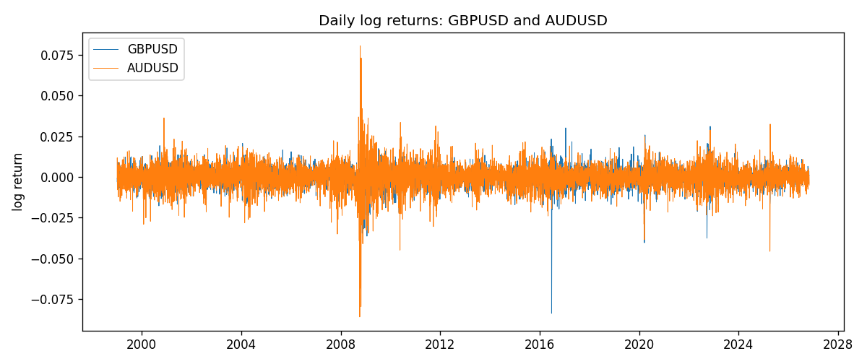
DCC rho path with Pearson r reference
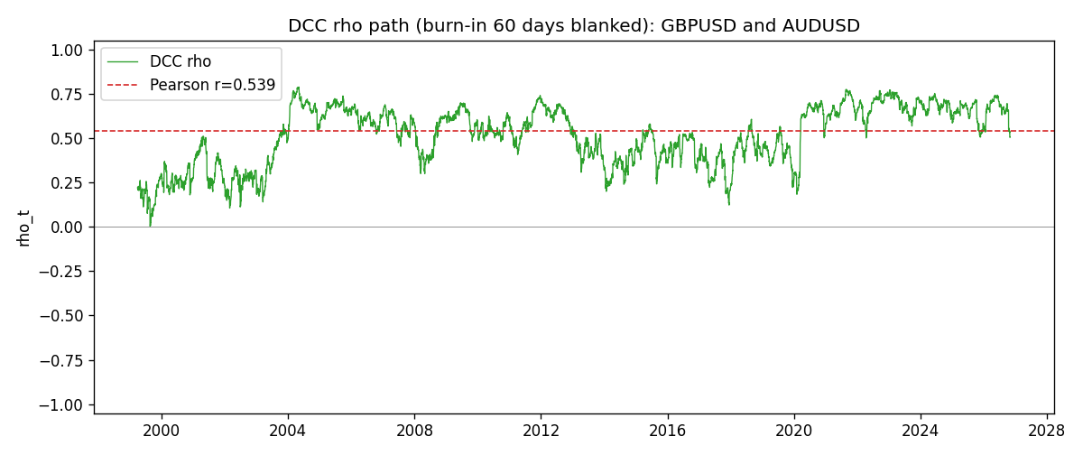

Data report
Every matched row that entered the DCC recursion is stored in the sibling Excel workbook named GBPUSD-AUDUSD_DCC_D1.xlsx. Embedding all rows as a Word table is impractical at this length; the Word file holds the column list, column summaries, and the first and last 15 matched rows.
Columns: time, GBPUSD_open, AUDUSD_open, GBPUSD_high, AUDUSD_high, GBPUSD_low, AUDUSD_low, GBPUSD_close, AUDUSD_close, GBPUSD_tick_volume, AUDUSD_tick_volume, GBPUSD_spread, AUDUSD_spread, GBPUSD_real_volume, AUDUSD_real_volume, GBPUSD_log_return, AUDUSD_log_return, GBPUSD_sigma, AUDUSD_sigma, GBPUSD_z, AUDUSD_z, q11, q22, q12, rho_t
Column summaries (matched calculation rows)
column | count | mean | std | min | 25% | 50% | 75% | max
GBPUSD_open | 7228 | 1.5166822 | 0.21834818 | 1.06854 | 1.3254025 | 1.51196 | 1.63237 | 2.1066
AUDUSD_open | 7228 | 0.75192541 | 0.13534725 | 0.4785 | 0.66102 | 0.7315 | 0.8091975 | 1.10284
GBPUSD_high | 7228 | 1.5229801 | 0.21891417 | 1.08366 | 1.3300275 | 1.518725 | 1.638825 | 2.1161
AUDUSD_high | 7228 | 0.75597511 | 0.13590934 | 0.4878 | 0.664695 | 0.734945 | 0.81552 | 1.10795
GBPUSD_low | 7228 | 1.5103473 | 0.21757706 | 1.03518 | 1.32009 | 1.50469 | 1.624985 | 2.0983
AUDUSD_low | 7228 | 0.74786335 | 0.13465689 | 0.4775 | 0.6577 | 0.72762 | 0.804475 | 1.0975
GBPUSD_close | 7228 | 1.5167386 | 0.2183035 | 1.06879 | 1.32568 | 1.51203 | 1.6324775 | 2.1065
AUDUSD_close | 7228 | 0.75196864 | 0.13532707 | 0.4786 | 0.6611875 | 0.731775 | 0.809315 | 1.10169
GBPUSD_tick_volume | 7228 | 94565.268 | 153330.81 | 62 | 9974.5 | 52775.5 | 91622.5 | 1273370
AUDUSD_tick_volume | 7228 | 77126.179 | 137934.11 | 109 | 5406 | 43250.5 | 71246.75 | 1234623
GBPUSD_spread | 7228 | 27.003182 | 19.183813 | 0 | 11 | 20 | 50 | 50
AUDUSD_spread | 7228 | 30.855562 | 16.875394 | 0 | 13 | 30 | 50 | 50
GBPUSD_real_volume | 7228 | 3.5428062e+09 | 8.4280615e+10 | 0 | 0 | 0 | 0 | 2.4038164e+12
AUDUSD_real_volume | 7228 | 5.2225089e+09 | 1.2514647e+11 | 0 | 0 | 0 | 0 | 3.811512e+12
GBPUSD_log_return | 7228 | -2.954e-05 | 0.0056473 | -0.08388241 | -0.00313242 | 3.002e-05 | 0.00317333 | 0.03112653
AUDUSD_log_return | 7228 | 1.629e-05 | 0.00754363 | -0.08602525 | -0.00386494 | 0.00027649 | 0.00415111 | 0.0806166
GBPUSD_sigma | 7228 | 0.00539544 | 0.0016979 | 0.00300649 | 0.00447815 | 0.00503733 | 0.00577328 | 0.02198775
AUDUSD_sigma | 7228 | 0.00694206 | 0.00278483 | 0.00391282 | 0.00551915 | 0.00627033 | 0.00759406 | 0.03848611
GBPUSD_z | 7228 | -0.00705533 | 1.0000203 | -10.311384 | -0.60009235 | 0.00257884 | 0.60716216 | 4.9477396
AUDUSD_z | 7228 | -0.00469142 | 1.0001095 | -8.472305 | -0.60543351 | 0.04067797 | 0.63842203 | 5.0260311
q11 | 7228 | 1.0017467 | 0.17799394 | 0.57208582 | 0.90970695 | 0.98492959 | 1.0612065 | 3.1110821
q22 | 7228 | 1.0019015 | 0.16967692 | 0.65120266 | 0.89701294 | 0.97783905 | 1.0745366 | 2.2448651
q12 | 7228 | 0.51351808 | 0.19230413 | 0.0035856 | 0.37713058 | 0.5279658 | 0.63838837 | 1.1674529
rho_t | 7228 | 0.5110589 | 0.16635483 | 0.00350213 | 0.38775252 | 0.53565815 | 0.65553053 | 0.78739208
First 15 matched rows (selected columns)
time | GBPUSD_log_return | AUDUSD_log_return | GBPUSD_sigma | AUDUSD_sigma | GBPUSD_z | AUDUSD_z | q11 | q22 | q12 | rho_t
1999-01-05 | -0.0028966287 | -0.00080418179 | 0.0040771459 | 0.0062640101 | -0.71456228 | -0.13255951 | 1 | 1 | 0.51244324 | 0.51244324
1999-01-06 | -0.00060452184 | 0.011836351 | 0.0040459288 | 0.0061117468 | -0.15355382 | 1.9323736 | 0.99159038 | 0.98311845 | 0.50526532 | 0.51174124
1999-01-07 | -0.002118709 | 0.0088650256 | 0.0039603828 | 0.0065437728 | -0.53920418 | 1.3507274 | 0.97497223 | 1.0304208 | 0.49149773 | 0.49036343
1999-01-08 | -0.0058954193 | 0.00031515916 | 0.0039086144 | 0.0066893789 | -1.5125988 | 0.04320085 | 0.96326138 | 1.0440086 | 0.47057606 | 0.46925155
1999-01-11 | -0.0056851331 | 0.0072213815 | 0.004071875 | 0.0065181499 | -1.400308 | 1.1038729 | 0.98609271 | 1.0260189 | 0.46144507 | 0.45875778
1999-01-12 | 0.0022657001 | -0.0048608485 | 0.0042023198 | 0.0065620517 | 0.53516969 | -0.74473975 | 1.0028686 | 1.0292786 | 0.42704926 | 0.42032914
1999-01-13 | 0.0091330396 | -0.0078902098 | 0.0041407409 | 0.0064919368 | 2.2016093 | -1.2194176 | 0.99055192 | 1.021068 | 0.4130215 | 0.41068298
1999-01-14 | 0.0019376331 | -0.002696916 | 0.0045812386 | 0.0065809481 | 0.41929427 | -0.41378359 | 1.0568382 | 1.0290347 | 0.3599774 | 0.34518821
1999-01-15 | -0.0017558204 | 0.007123101 | 0.0044913835 | 0.0064435806 | -0.39465932 | 1.1013952 | 1.0415931 | 1.0142403 | 0.35109456 | 0.34158958
1999-01-18 | 0.0012112405 | 0.00094592471 | 0.0044025296 | 0.0064870166 | 0.27132003 | 0.14178358 | 1.0262938 | 1.0176304 | 0.33789294 | 0.33063454
1999-01-19 | 0.0018745281 | 0.0072225153 | 0.0043070466 | 0.0063266762 | 0.43133551 | 1.1374603 | 1.0098745 | 1.0004565 | 0.33307305 | 0.33136504
1999-01-20 | -0.0049053846 | 0.0012507819 | 0.0042293638 | 0.006384056 | -1.1637993 | 0.19182313 | 0.99569989 | 1.0054966 | 0.33611463 | 0.3359177
1999-01-21 | 0.0031518998 | 0.00078094498 | 0.0042918011 | 0.0062304736 | 0.7304984 | 0.1211421 | 1.0018721 | 0.98884071 | 0.32683148 | 0.32836327
1999-01-22 | 0.0024781662 | -0.012252745 | 0.0042565717 | 0.0060790182 | 0.57826354 | -2.019885 | 0.99382256 | 0.97212193 | 0.32308189 | 0.32869858
1999-01-25 | 0.0012066366 | -0.0039591468 | 0.0041986817 | 0.0065601452 | 0.28339626 | -0.60750472 | 0.98250269 | 1.025577 | 0.29781232 | 0.29668231
Last 15 matched rows (selected columns)
time | GBPUSD_log_return | AUDUSD_log_return | GBPUSD_sigma | AUDUSD_sigma | GBPUSD_z | AUDUSD_z | q11 | q22 | q12 | rho_t
2026-10-13 | 0.0036434319 | 0.0035007712 | 0.0036716952 | 0.0045180377 | 0.98774155 | 0.76905043 | 0.76009092 | 0.76346038 | 0.49732549 | 0.65285194
2026-10-14 | -0.0049164679 | -0.0015193215 | 0.003701232 | 0.0045057963 | -1.3328573 | -0.34300125 | 0.76424176 | 0.76094523 | 0.50186085 | 0.65809901
2026-10-15 | 0.0065976411 | -0.0075447063 | 0.0038106787 | 0.0044377836 | 1.7269614 | -1.7060045 | 0.78207537 | 0.75033664 | 0.50111266 | 0.65415851
2026-10-16 | 0.0037592051 | 0.0033906408 | 0.0040420246 | 0.0046889977 | 0.92588725 | 0.71752401 | 0.82029067 | 0.7879202 | 0.44189681 | 0.54966219
2026-10-19 | -0.0017500314 | 0.0050859986 | 0.0040508301 | 0.0046624311 | -0.43615194 | 1.0852335 | 0.82126094 | 0.78362295 | 0.44585073 | 0.5557703
2026-10-20 | 0.0055923442 | 0.0034620426 | 0.0039841019 | 0.0047169683 | 1.3994618 | 0.72840649 | 0.81075067 | 0.79079833 | 0.43018014 | 0.53724679
2026-10-21 | 0.0012476328 | 0.0036066384 | 0.0041135761 | 0.0046914989 | 0.2992255 | 0.76318171 | 0.83082556 | 0.78671664 | 0.4404579 | 0.54480403
2026-10-22 | 0.00022396082 | -0.0012672558 | 0.0040325766 | 0.0046731615 | 0.051385224 | -0.27677797 | 0.81840286 | 0.783604 | 0.43694752 | 0.54562893
2026-10-23 | -0.0021146949 | 0.0023765656 | 0.0039452618 | 0.0045930948 | -0.54025335 | 0.51172323 | 0.80472361 | 0.77185855 | 0.42933553 | 0.54475923
2026-10-26 | -0.0024340661 | -0.0032032829 | 0.0038942116 | 0.0045389276 | -0.62934743 | -0.71150181 | 0.79627494 | 0.76352014 | 0.41736236 | 0.53526827
2026-10-27 | -0.0023648393 | 0.0016669876 | 0.0038565321 | 0.0045159581 | -0.61754583 | 0.36333715 | 0.7897778 | 0.75953975 | 0.41806225 | 0.53977559
2026-10-28 | 0.0015771808 | 0.0040915541 | 0.0038186493 | 0.0044492337 | 0.40863528 | 0.91372628 | 0.78315154 | 0.74920475 | 0.40719877 | 0.53159794
2026-10-29 | 0.0035881935 | -0.0040915541 | 0.0037592339 | 0.0044672224 | 0.95004665 | -0.92176436 | 0.7729677 | 0.75114457 | 0.40681377 | 0.53389175
2026-10-30 | 0.0013450605 | 0.0010102376 | 0.0037793493 | 0.0044865061 | 0.35146645 | 0.2193389 | 0.77561811 | 0.75330096 | 0.38497221 | 0.50364108
2026-11-02 | 0.0010971256 | -0.0049184984 | 0.0037170376 | 0.0044110453 | 0.29065609 | -1.1209748 | 0.76483106 | 0.74164302 | 0.37991926 | 0.50444183

